SCENARIO 2 - FOREST FIRE
- 30% decrease in rainfall in winters leads to drier soils, which can stress vegetation and make forests more susceptible to fires. The lack of sufficient winter precipitation can prolong the duration of fire-prone conditions, causing the fire season to start earlier and end later than usual. Based on the seasonal outlook issued in January 2026, overall countrywide below average rainfall coupled with above normal temperatures with unprecedented high temperatures anticipated in the month of May and June are expected. In addition to that, Exceptionally Low Relative humidity levels will prevail, contributing to dryness and heightened fire risks. Anticyclonic dry winds, low humidity, elevated temperature and low probabilities of rainfall will create conducive environment for forest fire during May and June.
- On March 5, 2026, DEW-2 was issued forecasting below-normal rainfall and prolonged dry spells in the coming months across parts of KP, the Potohar region, AJK, and Balochistan.
- On May 8, 2026, a confirmatory forest fire alert was issued based on prevailing dry meteorological conditions for the forested areas of Punjab, Khyber Pakhtunkhwa, and the Muzaffarabad (AJK). The fire is anticipated to occur between May 10 and May 25, 2025.

DEW Issue Date | Type of Advisory | Monitored Indicators | Remarks
March 5,2026 | DEW-2  (April-June) | Above Average Temperature  - Low relative humidity  - Elevated air and land surface temperatures  - Low probabilities of rainfall | Fire Danger Rating Index (FDRI) highlights moderate risks due to:  - Prolonged dry spells  - Unprecedented high temperatures anticipated for May and June  - Conducive conditions for forest fires
18 April 2026 | Advisory Forecast  (May-June) | - Below-normal rainfall  - Prolonged dry spells  - Elevated temperatures  - Exceptionally low relative humidity | Fire Danger Rating Index (FDRI) indicates increased risk with thresholds:  - Temperature exceeding 35°C  - Relative humidity dropping below 20%  - Increasing dryness contributing to heightened fire risks
8 May 2026 | Confirmatory Forest Fire Alert | - Elevated temperatures  - Exceptionally low relative humidity  - Anticyclonic dry air mass  - Higher upper-level atmospheric pressure  - High geopotential height | Fire Danger Rating Index (FDRI) indicates high risk with thresholds:  - Temperature exceeding 40°C  - Relative humidity dropping to 10% or lower  - Wind speeds reaching or exceeding 25 km/h  - Atmospheric pressure surpassing 1013 hPa  - Favourable conditions for rapid fire spread and intensity

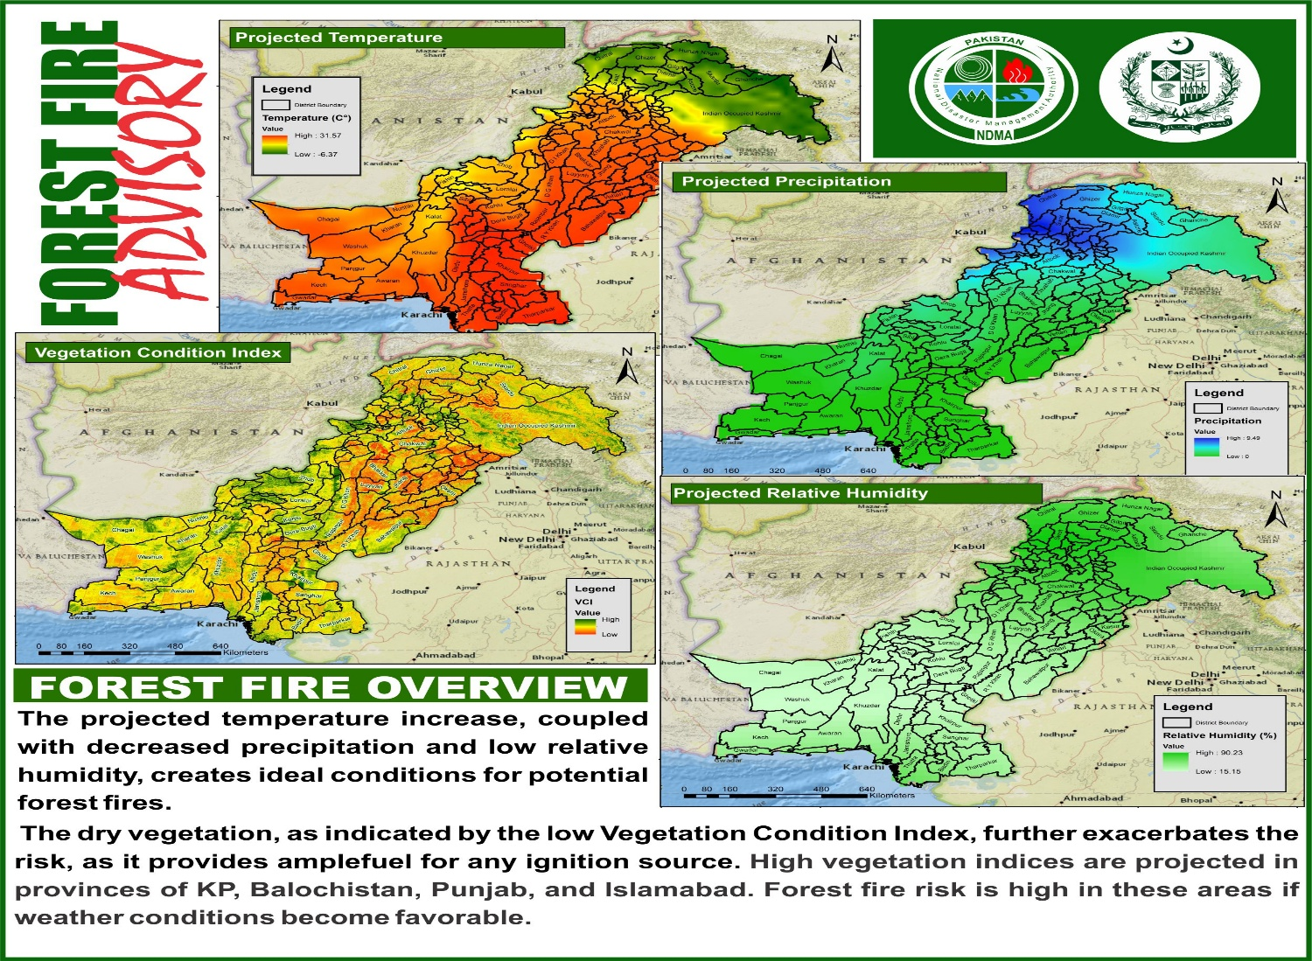

Forest of Kotli Sattian. A forest fire ignited in the Kotli Sattian forest on the afternoon of May 14, 2026. The forest primarily comprises deciduous and needle-leaf trees, which shed their leaves in the summer to conserve moisture. However, the accumulation of dry leaves and tree bark is providing ample fuel for the fire to intensify. The prevailing meteorological conditions are exacerbating the situation, with south-eastern winds blowing at 5-6 km/h and temperatures reaching 39-40°C. The fire currently threatens an area of 5.1 km.

Total Pop. | Hospital | School | Settlements | Road (km)
4158 | 1 | 8 | 2 | 58
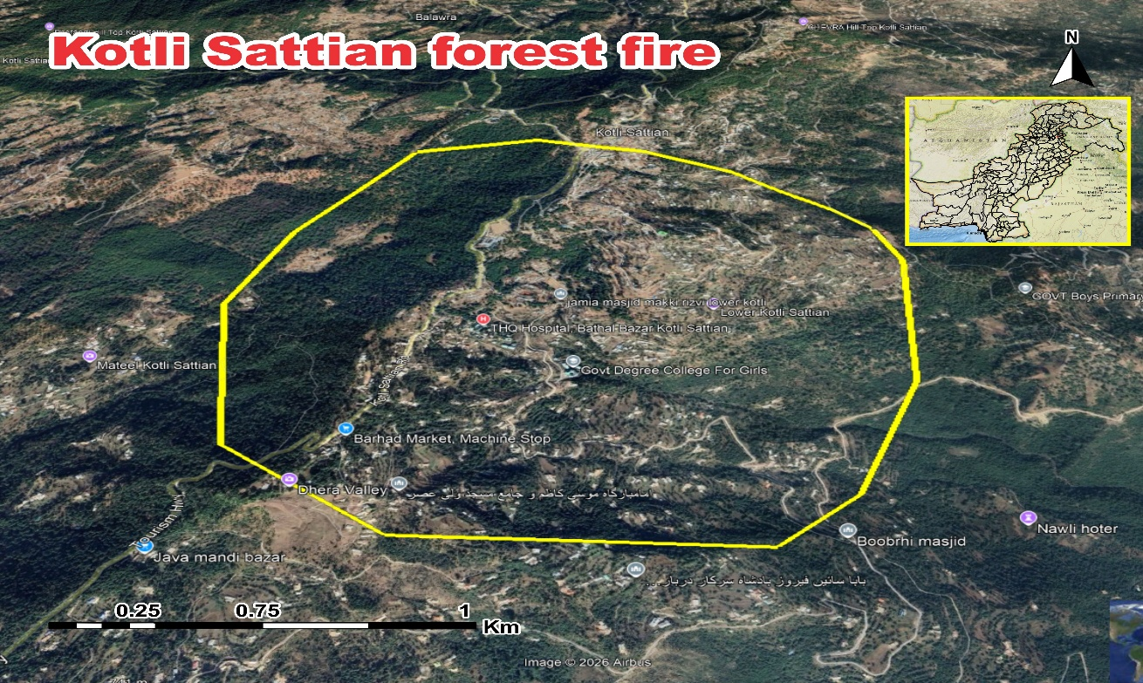Choose another country or region to see content specific to your location and shop online.
Top of Form
ContinueDismiss
Bottom of Form
IQAir Logo
Air Quality
Air Monitors
Air Purifiers
Filters
Face Masks
For Business
News
Impact
Top of Form
Bottom of Form

Sign in
Click to open cart

World AQI⁺ Ranking
Last update at 08:39, Jan 20

Forest of Kotli (AJK). A forest fire erupted in the forest of Kotli (AJK) on May 23, 2026, with temperatures soaring to 37-38°C and south-westerly winds blowing at speeds of 8-9 km/h. The fire is likely to intensify and spread rapidly, affecting an area of 6.5 km. Forest fire erupts in the forested area of Shensa valley The accumulation of dry leaves, tree bark, and other residues is providing abundant fuel for the fire to grow stronger. These conditions, combined with elevated temperatures, low relative humidity, and the presence of dry winds, pose a significant threat to the natural habitat, nearby communities, and the ecological balance of the region. Immediate containment efforts are essential to minimize the damage and prevent further escalation of the fire.
Total Pop. | Hospital | School | Settlements | Road (km)
10,141 | 1 | 11 | 10 | 34

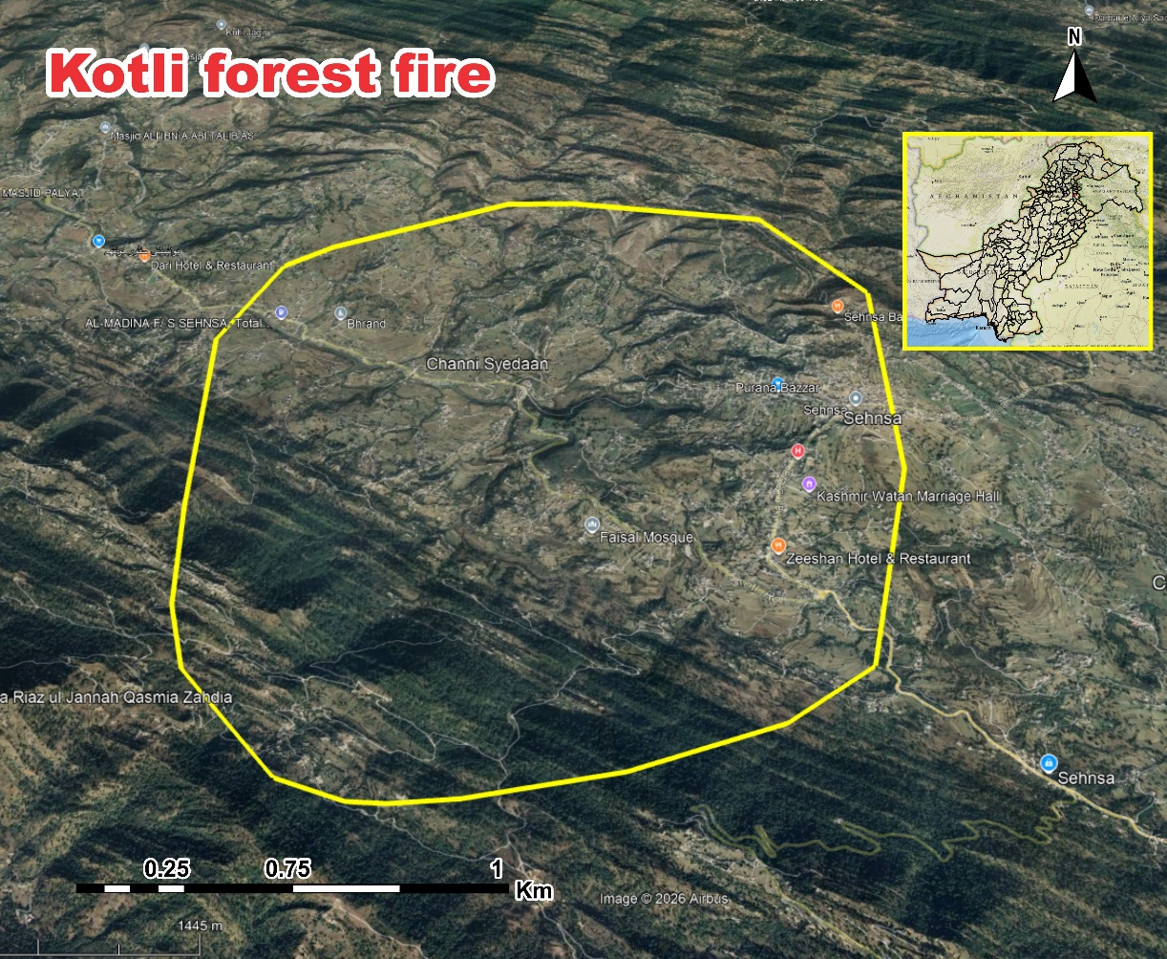

Forest of Swat. A forest fire erupted in the forest of Swat on May 27, 2026, with temperatures soaring to 39-40°C and south-westerly winds blowing at speeds of 10-12 km/h. The fire is likely to intensify and spread rapidly, affecting an area of 8.2km near Shingardar Village. The accumulation of dry leaves, tree bark, and other residues is providing abundant fuel for the fire to grow stronger. These conditions, combined with elevated temperatures, low relative humidity, and the presence of dry winds, pose a significant threat to the natural habitat, nearby communities, and the ecological balance of the region. Immediate containment efforts are essential to minimize the damage and prevent further
Total Pop. | Hospital | School | Settlements | Road (km)
23,722 | - | - | 5 | -

